Assignment

PIN : 2503A52L04
Test-Driven Development with AI – Generating and Working with Test Cases :
Task #1 :
(Password Strength Validator – Apply AI in
Security Context)
• Task: Apply AI to generate at least 3 assert test cases for
is_strong_password(password) and implement the validator
function.
• Requirements:
o Password must have at least 8 characters.
o Must include uppercase, lowercase, digit, and special
character.
o Must not contain spaces.
Example Assert Test Cases:
assert is_strong_password("Abcd@123") == True
assert is_strong_password("abcd123") == False
assert is_strong_password("ABCD@1234") == True
Expected Output #1:
• Password validation logic passing all AI-generated test cases

Code & Output :

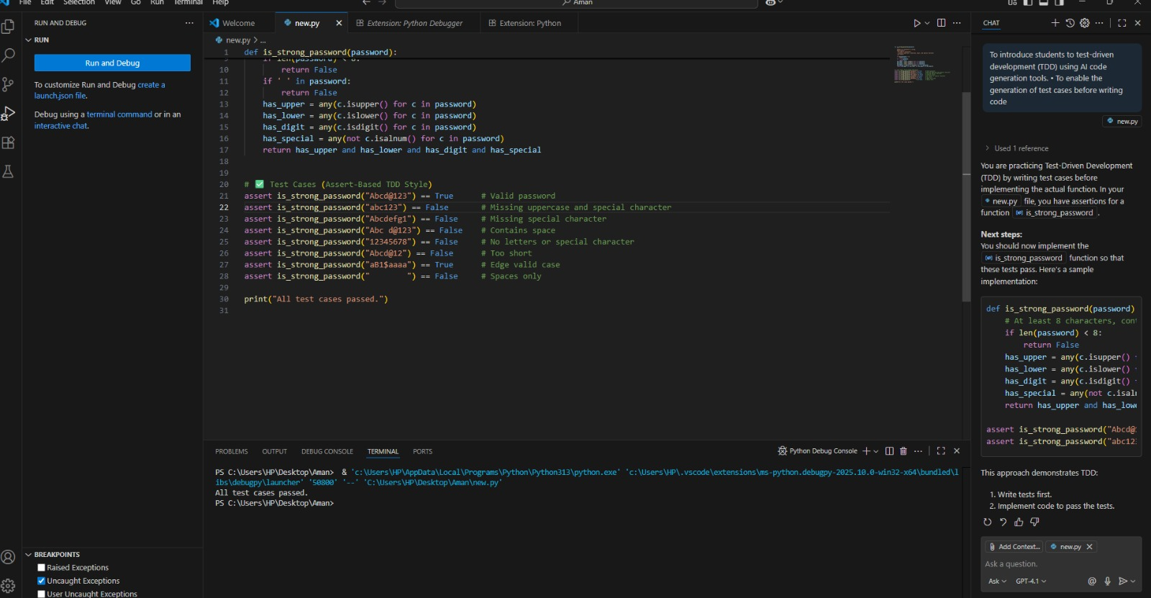

Task #2 :
(Number Classification with Loops – Apply AI for
Edge Case Handling)
- Task: Use AI to generate at least 3 assert test cases for a
classify_number(n) function. Implement using loops.
• Requirements:
- Classify numbers as Positive, Negative, or Zero.
- Handle invalid inputs like strings and None.
- Include boundary conditions (-1, 0, 1).
Example Assert Test Cases:
assert classify_number(10) == "Positive"
assert classify_number(-5) == "Negative"
assert classify_number(0) == "Zero"

Expected Output #2:
• Classification logic passing all assert tests.
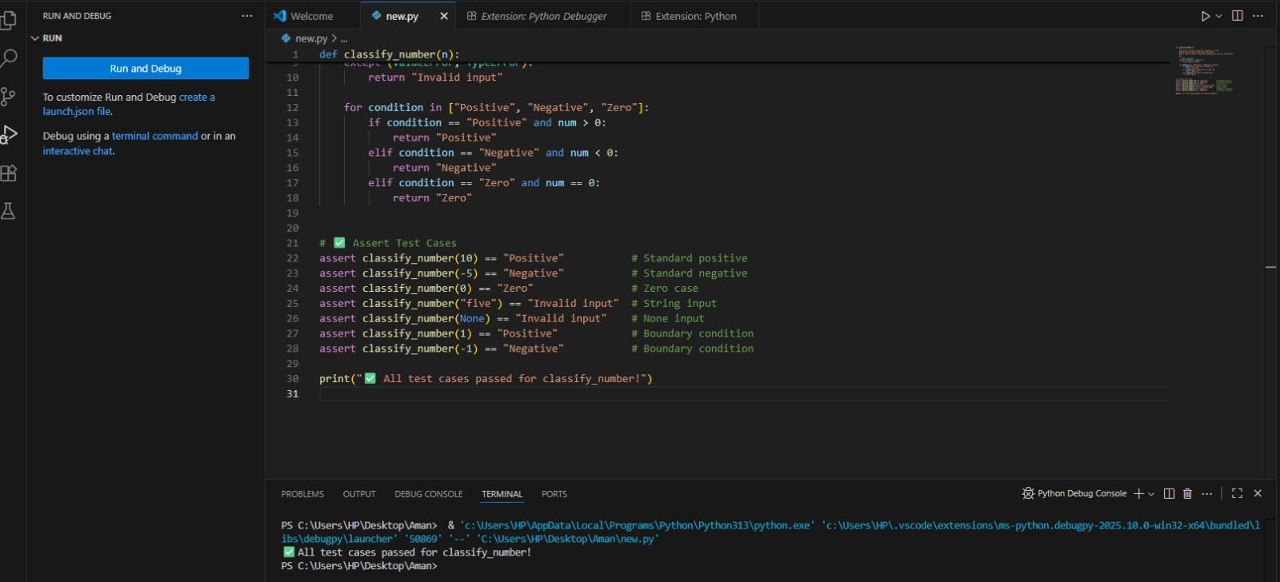
Task #3 :
(Anagram Checker – Apply AI for String Analysis)
• Task: Use AI to generate at least 3 assert test cases for
is_anagram(str1, str2) and implement the function.
• Requirements:
o Ignore case, spaces, and punctuation.
o Handle edge cases (empty strings, identical words).
Example Assert Test Cases:
assert is_anagram("listen", "silent") == True
assert is_anagram("hello", "world") == False
assert is_anagram("Dormitory", "Dirty Room") == True
Expected Output #3:
• Function correctly identifying anagrams and passing all AI-
generated tests.
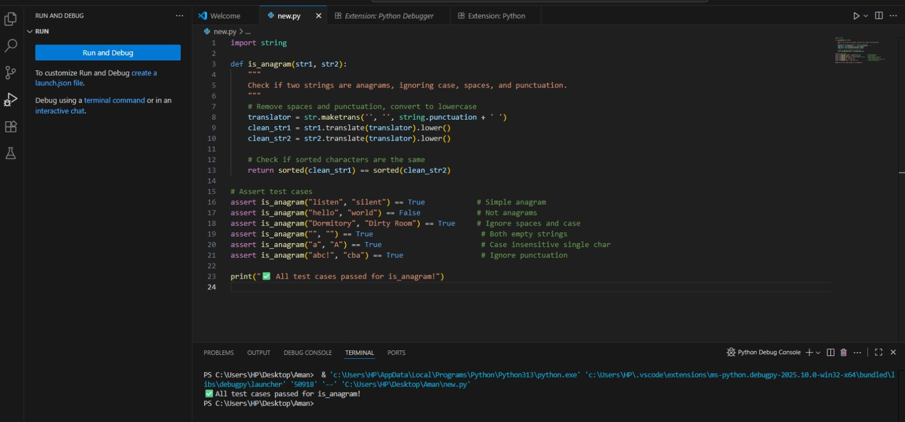

Task #4 :

(Inventory Class – Apply AI to Simulate Real-
World Inventory System)
• Task: Ask AI to generate at least 3 assert-based tests for an
Inventory class with stock management.
• Methods:
o add_item(name, quantity)
o remove_item(name, quantity)
o get_stock(name)
Example Assert Test Cases:
inv = Inventory()
inv.add_item("Pen", 10)
assert inv.get_stock("Pen") == 10
inv.remove_item("Pen", 5)
assert inv.get_stock("Pen") == 5
inv.add_item("Book", 3)
assert inv.get_stock("Book") == 3
Expected Output #4:
• Fully functional class passing all assertions

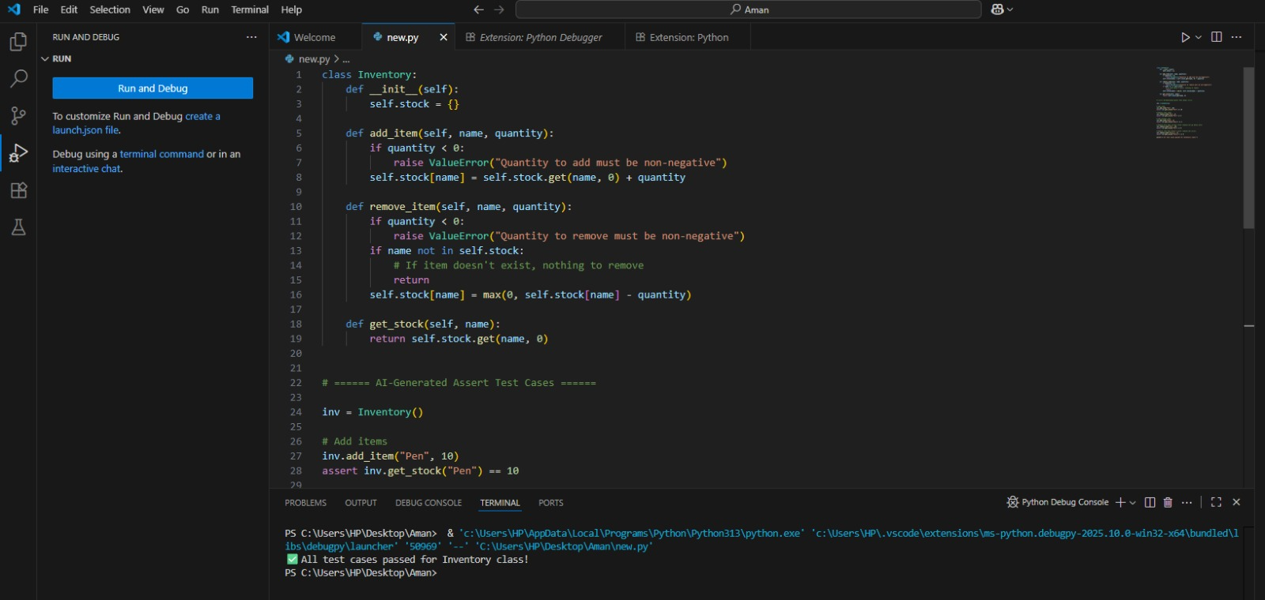

Task #5:

(Date Validation & Formatting – Apply AI for
Data Validation)
• Task: Use AI to generate at least 3 assert test cases for
validate_and_format_date(date_str) to check and convert dates.
• Requirements:
o Validate "MM/DD/YYYY" format.
o Handle invalid dates.
o Convert valid dates to "YYYY-MM-DD".
Example Assert Test Cases:
assert validate_and_format_date("10/15/2023") == "2023-10-15"
assert validate_and_format_date("02/30/2023") == "Invalid Date"
assert validate_and_format_date("01/01/2024") == "2024-01-01"
Expected Output #5:
• Function passes all AI-generated assertions and handles edge
cases.
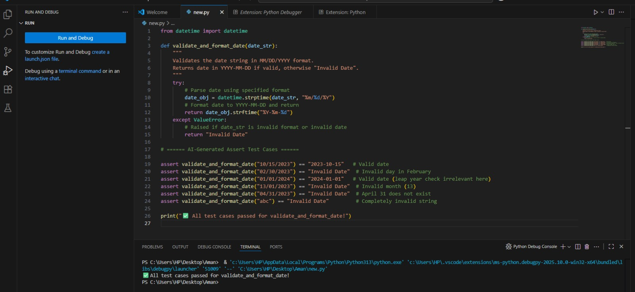

Observation:

Task 1 – Password Strength Validator
The function successfully validated password strength using rules for length, uppercase, lowercase, digits, special characters, and no spaces. All test cases passed.
Task 2 – Number Classification
The function correctly classified numbers as Positive, Negative, or Zero, and handled invalid inputs like strings and None. Boundary conditions (-1, 0, 1) worked as expected.
Task 3 – Anagram Checker
The function correctly identified anagrams while ignoring spaces, case, and punctuation. Edge cases like empty strings and identical words were handled properly.
Task 4 – Inventory Class
The inventory system supported adding, removing, and checking stock. It also handled invalid quantities, missing items, and insufficient stock. All assertions passed.
Task 5 – Date Validation & Formatting
The function validated dates in MM/DD/YYYY format and converted them to YYYY-MM-DD. Invalid dates (like Feb 30, month=0, wrong day count) were rejected successfully.

